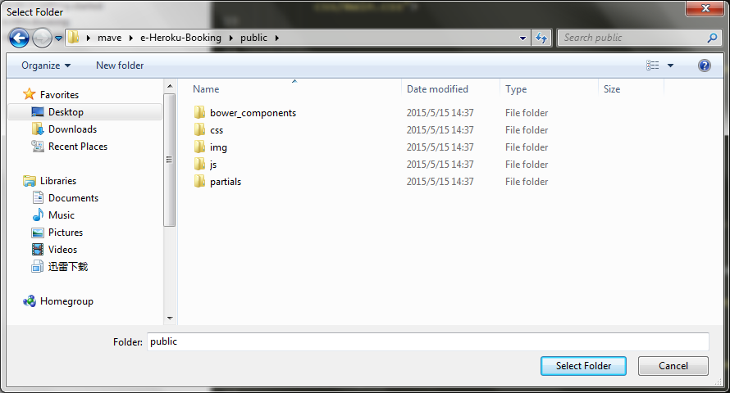

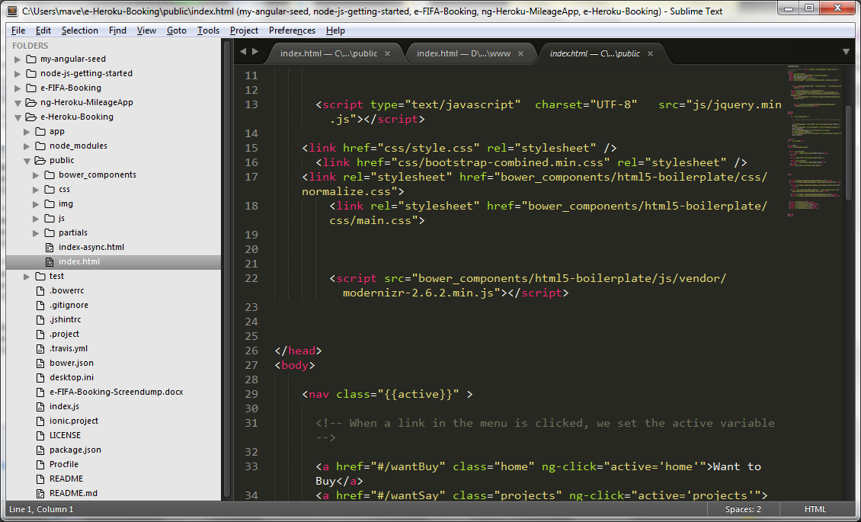

If heroku logs said: bower uninstalled, may be:

Reason:

<script src="bower_components/html5-boilerplate/js/vendor/modernizr-2.6.2.min.js"></script>

Check the path